Game Design Document

**Mine Over Matter**

**Genre:** Mining Sim/Adventure/Roguelike

**Target Audience:** Fans of Mining sims and Roguelike games

**Developers:**

Abby Sutton, Matthew Warn, Duane Belleza, Sam Hurd

Date: 27/05/2025

Table of Contents

Introduction: 3

Overview 3

Game Rules and Mechanics: 3

Core Gameplay Loop: 3

Progression: 4

Game Structure: 4

Player Journey: 4

Control Scheme: 4

User Interface Design: 4

Mock Interface and Sample Screens: 5

Key Algorithms: 5

Cheat Features: 5

Required Asset List: 5

Look and Feel: 5

Bibliography: 6

## Introduction:

Mine Over Matter is a roguelike mining sim adventure game where the player takes on the role of a Miner descending into dangerous caverns searching for a lost friend. Inspired by games like Minecraft*, Game 2 and Game 3*, it combines resource gathering, tool progressions and survival elements.

## Overview

**Genre:** Mining Sim/Adventure/Roguelike

**Target Audience:** Fans of mining sims, roguelikes and progression-based adventure games

**Platforms:** PC, Xbox Controller supported

**Developers:** Abby Sutton, Matthew Warn, Duane Belleza, Sam Hurd

**Core Gameplay:** Strategic digging, Resource management and survival

## Game Rules and Mechanics:

**Core Systems:**

* **Mining Mechanics:** Players can dig through different types of blocks whether it be dirt, stone and they have different resistance values the deeper depths the player goes through.
* **Stamina System:** Limited stamina that depletes depending on player’s actions (mining, running, jumping) and must be managed carefully otherwise the player loses.

**Hazards:**

* **Enemies:** Spiders with tracking AI that hurts the player and have a chance of spawning when a block is broken.
* **Lava:** Flowing lava found randomly within the mine and will kill the player if they mine into the lava.
* **Mines:** Spike mines found randomly within the mine that will kill the player if they mine into it.

## Core Gameplay Loop:

1. **Player prepares on the surface:**
   1. Upgrade tools, recover health/stamina, prepare to mine.
2. **Descends into the mines:**
   1. Dig strategically, collect resources and manage stamina while doing so.
3. **Survive in the mines/underground:**
   1. Manage stamina, avoid spiders.
4. **Return to the surface:**
   1. Make it back to the surface before stamina runs out.
5. **Player upgrades stats/tools and repeats:**
   1. Use resources collected to improve tools or player stats to get deeper dives and save friend.

## Progression:

## Game Structure:

**World Structure:**

* Surface Hub: Safe zone with upgrade stations and healing.

## Player Journey:

* Early Game
  + Player learns basic mechanics such as mining and digging their first couple holes.
* Mid Game
  + Players start to get a feel of how to mine, in which they start collecting resources to upgrade their tools.
* Late Game
  + Players will start pushing to the deepest depths of the game with most of the tools/stats near to max level.
* End Game
  + Discover the fate of the Miner’s friend and achieve closure.

## Control Scheme:

|  |  |  |
| --- | --- | --- |
| **Action** | **Keyboard** | **Xbox Controller** |
| Movement | WASD | Joystick |
| Mine Up | Up Arrow Key | D-pad Up |
| Mine Down | Down Arrow Key | D-pad Down |
| Mine Left | Left Arrow Key | D-pad Left |
| Mine Right | Right Arrow Key | D-pad Right |
| Inventory | *Placeholder* | *Placeholder* |
| Pause | Esc | *Placeholder (menu?)* |

## User Interface Design:

**HUD Elements:**

* Health Bar
* Stamina Bar
* Oxygen Bar
* Depth Meter
* Resource icons

**Menus:**

* Upgrade station
* Inventory
* Pause Menu

## Mock Interface and Sample Screens:

Cutscene progressions:

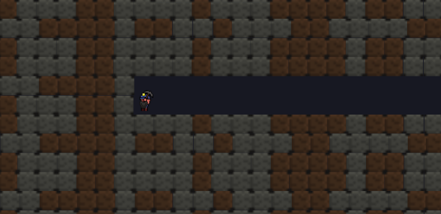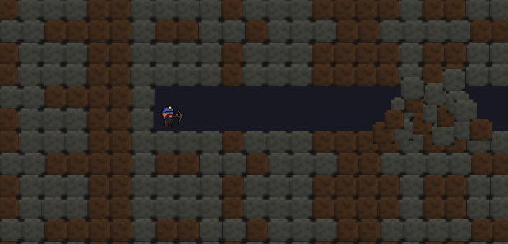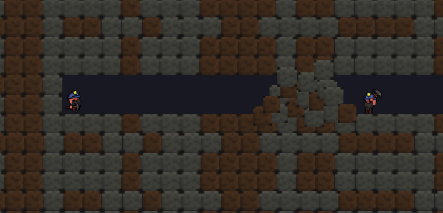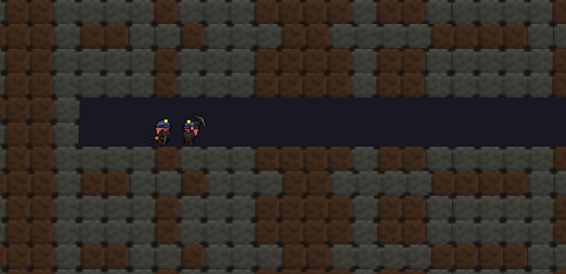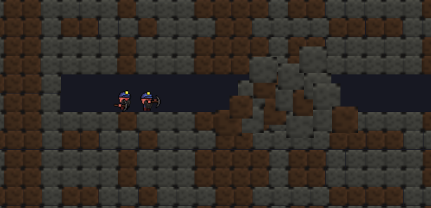

## Key Algorithms:

**Block finding within grid for block breaking:**

**Jumping code:**

**Particles:**

## Cheat Features:

1. God Mode
2. Infinite Health/Stamina
3. Infinite Resources
4. All upgrades unlocked
5. Instant Mining speed

## Required Asset List:

**Visual Assets**

* Player sprite
  + *Insert Link*
* Spider sprite
* Environmental tile sets
* Resource Icon sprites
* Hazard sprites

**Audio Assets**

* Title Screen BGM
* Button clicks
* Mine/Cave ambience

## Look and Feel:

**Art Style**

* The style of the game is pixelized giving a retro feel.

**Tone:**

* The Surface: Safe, bright
* Mines: Dark, occasional water droplets, dangerous

## Bibliography: